

Problems: UNIT 1

INTRODUCTION TO THE ALGORITHMICS



JAVIER GARCÍA JIMÉNEZ AND ISABEL MARTÍNEZ GÓMEZ

EXERCISE 3

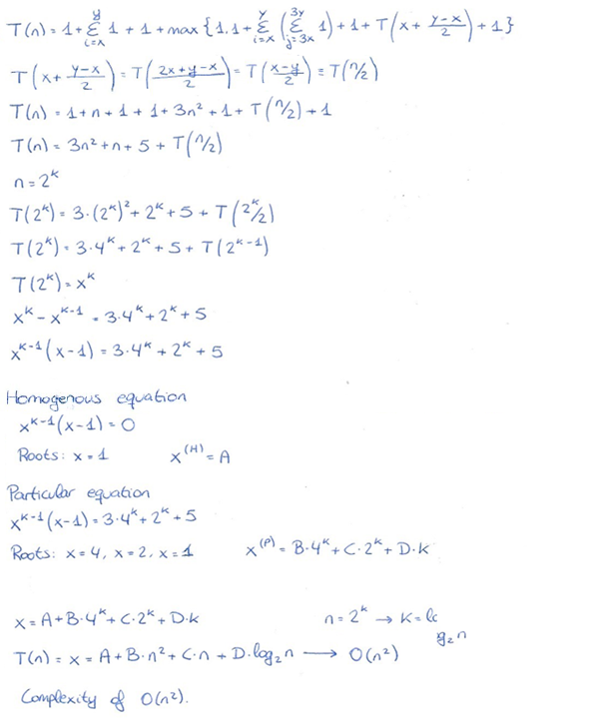

**Complexity of O(n2)**

EXERCISE 5

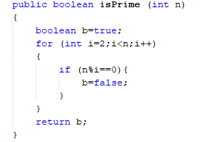

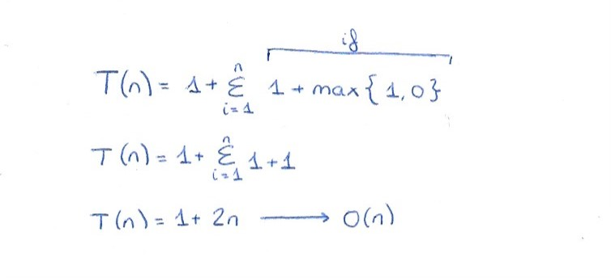

**Complexity of O(n)**

EXERCISE 8

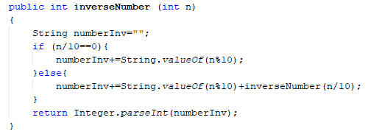

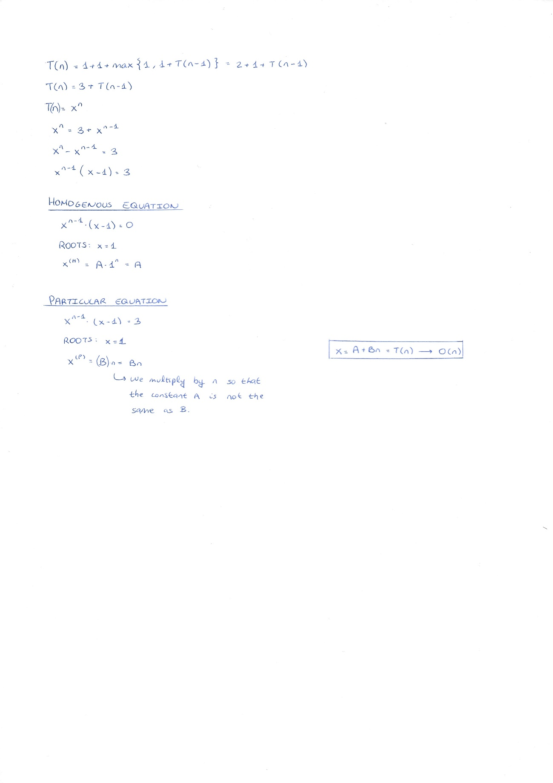

**Complexity of O(n)**

EXTRA EXERCISE: EXERCISE 7

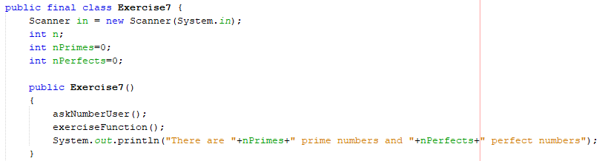

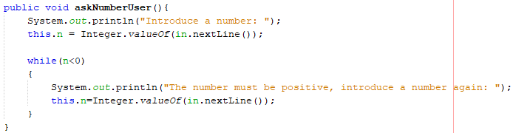

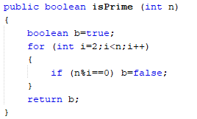

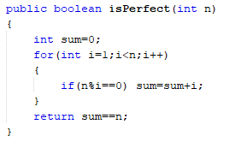

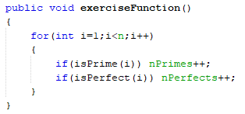

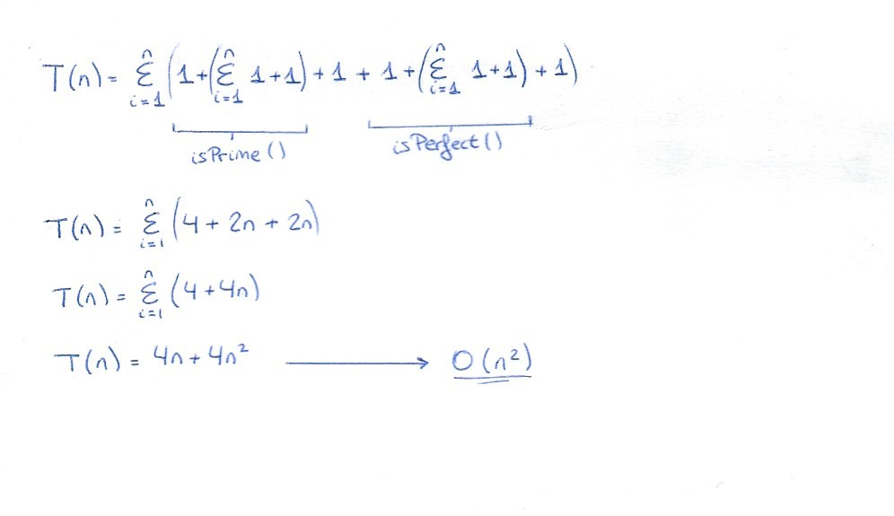

**The complexity of the exerciseFunction is of O(n2)**